**DAILY ONLINE ACTIVITIES SUMMARY**

|  |  |  |  |  |  |  |  |  |
| --- | --- | --- | --- | --- | --- | --- | --- | --- |
| **Date:** | **11/07/2020** | | | | | **Name:** | **RITIKA KULKARNI** | |
| **Sem & Sec** | **IV sem & B section** | | | | | **USN:** | **4AL19CS403** | |
| **Online Test Summary** | | | | | | | | |
| **Subject** | | **-** | | | | | | |
| **Max. Marks** | | **30** | | **Score** | | | **-** | |
| **Certification Course Summary** | | | | | | | | |
| **Course** | **Python** | | | | | | | |
| **Certificate Provider** | | | **Coursera** | | **Duration** | | | **5.5 hours** |
| **Coding Challenges** | | | | | | | | |
| **Problem Statement:**   1. **Write a Java program for Reversal algorithm for array rotation.** | | | | | | | | |
| **Status: Executed** | | | | | | | | |
| **Uploaded the report in Github** | | | | | **YES** | | | |
| **If yes Repository name** | | | | | <https://github.com/ritikakulkarni> | | | |
| **Uploaded the report in slack** | | | | | **YES** | | | |

**Online Test Summary**: No internals conducted today.

**Online Certification Course Summary:** I have taken new Online Certification Course in **coursera** . Today I went through Installing of Python.

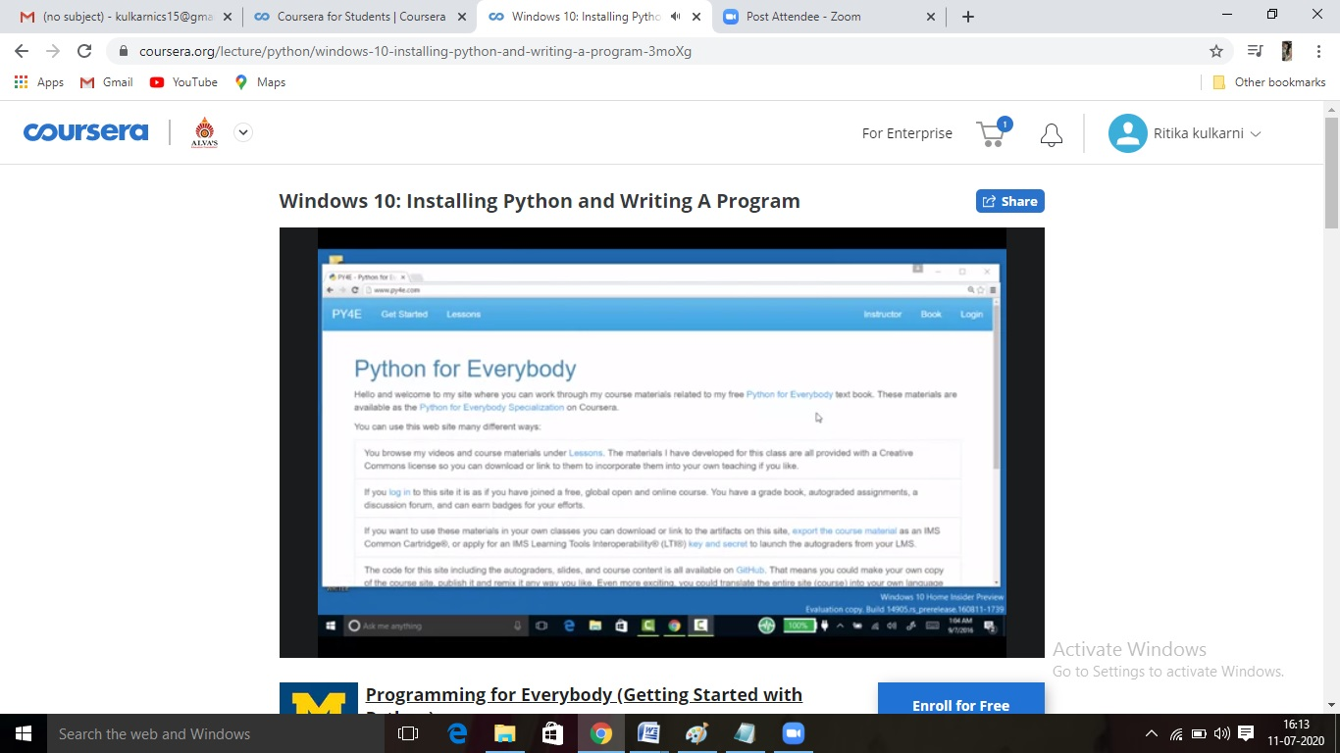

This is the snapshot of today’s session.

**Online Coding Summary:** Today I received one program from Prof. Shilpa Mam CSE Dept.. I have written one program and uploaded it to my Github repository. This is my repository snapshot. I have uploaded the frequency program.

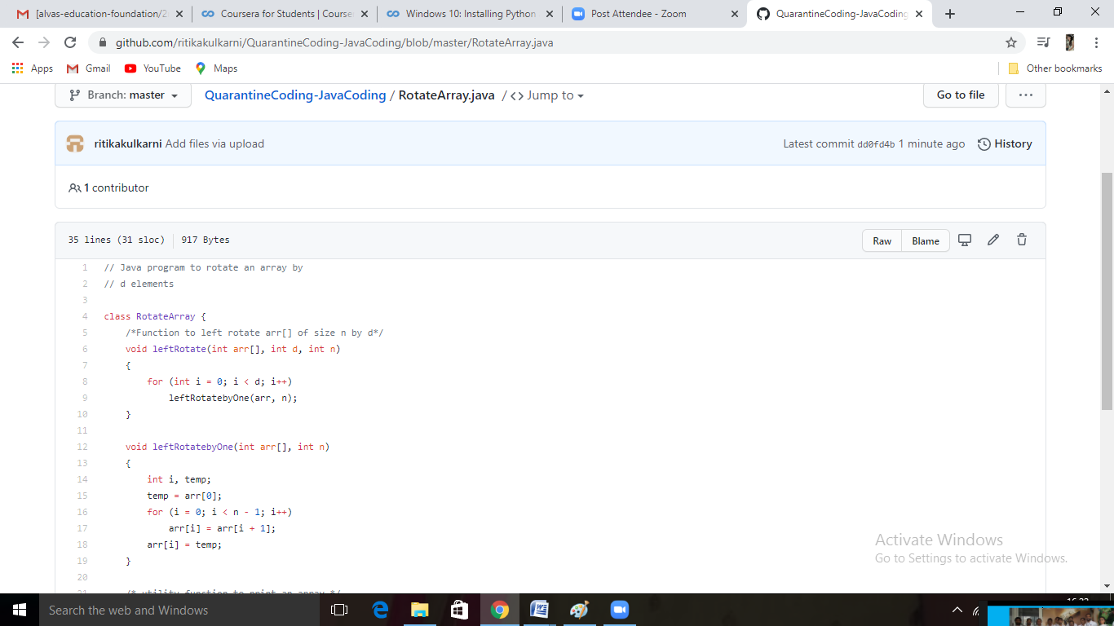

Thank you